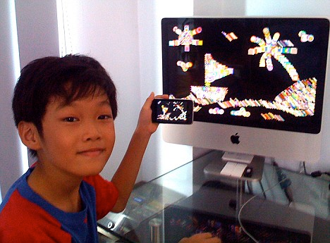
Young Inventors: Computer whiz-kid, 9, creates popular application for iPhone

Most children his age may draw pictures on paper with crayons, but nine-year-old Lim Ding Wen has a very different canvas. The primary school pupil from Singapore writes applications for Apple's iPhone. His latest project, a painting programme called Doodle Kids, has been downloaded over 4,000 times from Apple's iTunes store in just two weeks.

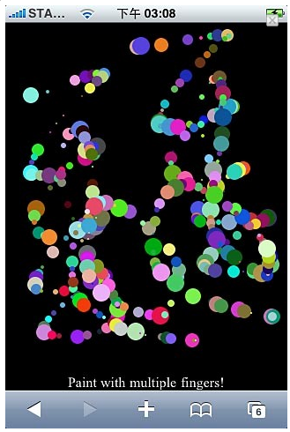
iPhone users can draw with their fingers by simply touching the iPhone's touchscreen. They can create squares, circles, lines, triangles and stars of different sizes and colours. Pressing the space key animates the picture and pressing delete or shaking the phone clears it.
'I wrote the programme for my younger sisters, who are into drawing' Lim said. His sisters are aged three and five.
Lim, who is fluent in six programming languages including ActionScript and JavaScript, is thought to be the world's youngest Apple programmer. He first used a computer at just two years old and began learning programming by the time he was seven.

He has since completed about twenty programming projects. One of his games called Paddle is modeled on the famous arcade game Pong. His father, Lim Thye Chean, a chief technology officer at a local technology firm, also writes iPhone applications. 'Every evening we check the statistics emailed to us (by iTunes) to see who has more downloads,' the older Lim said.
(source: http://www.dailymail.co.uk/sciencetech/article-1136105/Computer-whizz-kid-9-creates-popular-application-iPhone.html, adapted)

Tasks:
- Is this text written in British English or American English? Give reasons for your answer.
- Which of these pictures shows a canvas?

- 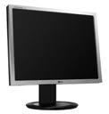 b) c) d) 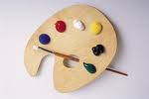
- Find examples for present participles (underline them green) and past participles (red)
- Do you think his app is any good? Give a good reason for your answer.
- What languages are you fluent in?
- In which way are father and son competing?
- More inventions: Visit http://gadgetsgiftstoys.mailonline.co.uk/ and find
- a silly present b) a present for your parents and c) a present for your best friend … and write down why it’s silly/good for your parents/friends.

